**Actual individual consumption per capita in 2023**

In 2023, [actual individual consumption](https://ec.europa.eu/eurostat/statistics-explained/index.php?title=Glossary:Actual_individual_consumption_(AIC)) (AIC) per capita expressed in [purchasing power standards](https://ec.europa.eu/eurostat/statistics-explained/index.php?title=Glossary:Purchasing_power_standard_(PPS)) (PPS) varied from 70% to 138% of the EU average across the 27 EU countries. For Bulgaria, the level is 27% below the EU average, according to the nowcast estimates for 2023.

AIC includes all goods and services that households use, irrespective of whether they were purchased and paid for by households directly, by government, or by nonprofit organizations. It can be considered as an indicator of the material welfare of households.

This information comes from recently published [data on purchasing power parities](https://ec.europa.eu/eurostat/web/purchasing-power-parities/database) (PPP). This article presents some of the findings from the more detailed account in the Statistics Explained article.

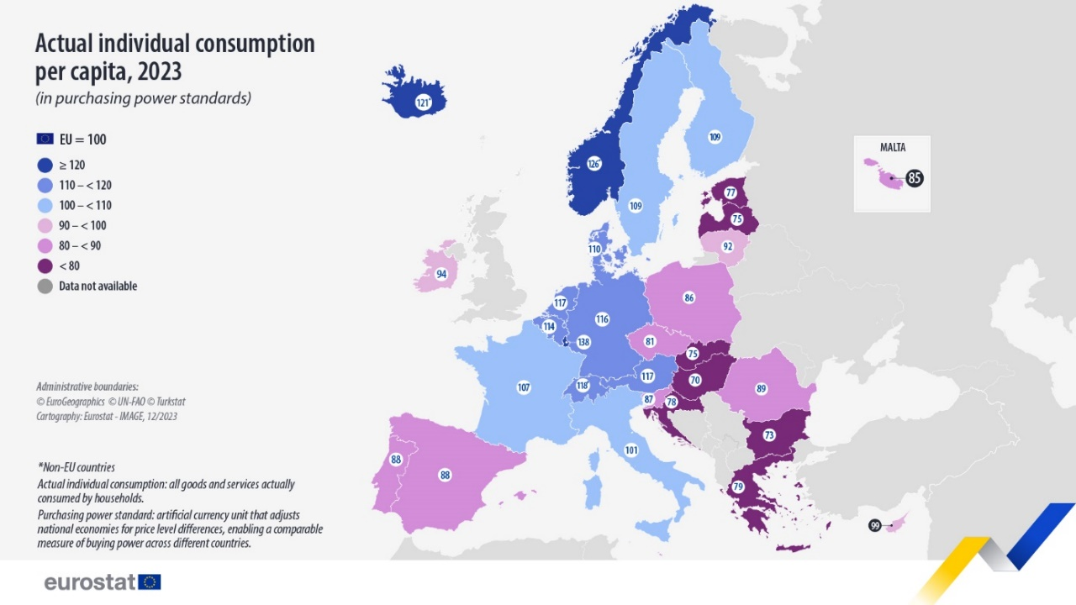

In 2023, 10 EU countries recorded AIC per capita above the EU average. The highest levels were recorded in Luxembourg (38% above the EU average), Austria and the Netherlands (both 17%).

Meanwhile, 17 EU countries recorded AIC per capita below the EU average, with the lowest levels recorded in Hungary (30% below the EU average), Bulgaria (27%), Slovakia and Latvia (both 25%).

**Luxembourg and Ireland record the highest GDP per capita**

In 2023, GDP per capita in Bulgaria is 36% below the EU-27 average. [Gross domestic product](https://ec.europa.eu/eurostat/statistics-explained/index.php?title=Glossary:Gross_domestic_product_(GDP)) (GDP) per capita, a measure of economic activity, also showed substantial differences across the EU members.

GDP per capita above the EU average was recorded in 11 EU countries. It was highest in Luxembourg (139% higher than the EU average), Ireland (111%) and the Netherlands (30%). At the other end of the range, the lowest GDP per capita was recorded in Bulgaria (36% below the EU average), Greece (33%) and Latvia (29%).

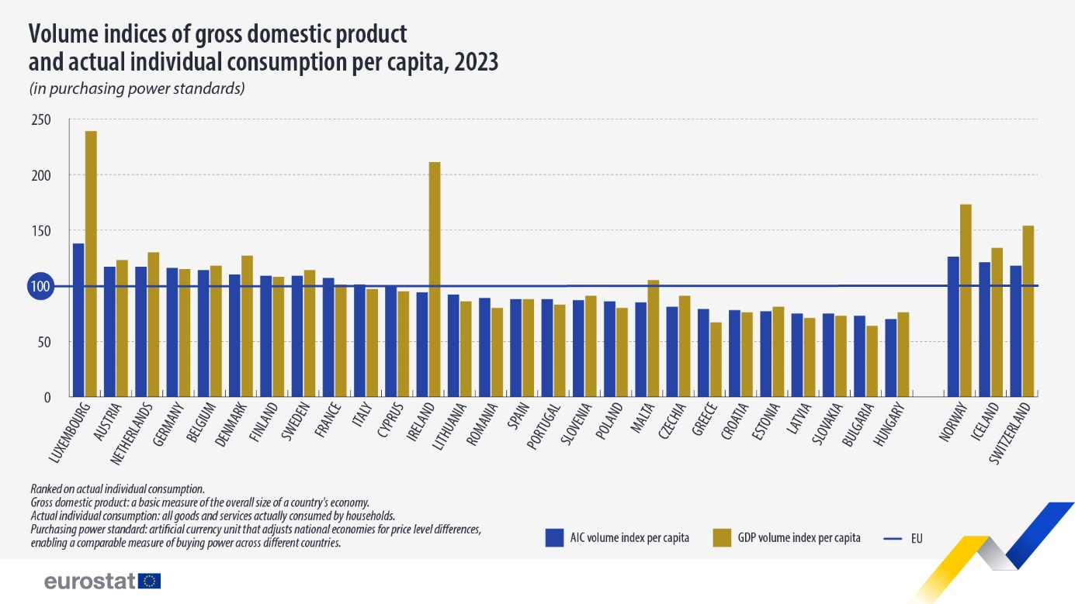

Source dataset: [prc_ppp_ind](https://ec.europa.eu/eurostat/databrowser/bookmark/d1cadb07-fbfa-43b6-820a-3a343891f153?lang=en)

**For more information**

* [Statistics Explained article on consumption and GDP per capita](https://ec.europa.eu/eurostat/statistics-explained/index.php?title=GDP_per_capita,_consumption_per_capita_and_price_level_indices)
* [Thematic section on purchasing power parities](https://ec.europa.eu/eurostat/web/purchasing-power-parities/overview)
* [Database on purchasing power parities](https://ec.europa.eu/eurostat/web/purchasing-power-parities/database)
* [Metadata on purchasing power parities](https://ec.europa.eu/eurostat/cache/metadata/en/prc_ppp_esms.htm)
* [Statistics 4 beginners on GDP](https://ec.europa.eu/eurostat/statistics-explained/index.php?title=Beginners:GDP)

**Methodological notes**

The provisional estimates for 2023 presented in this news article are based on GDP and population data for 2023, extracted on 11 June 2024, and the most recent PPPs available. Revised estimates will be published in December 2024.  
   
If you have any queries, please visit our [contact us](https://ec.europa.eu/eurostat/web/main/contact-us) page